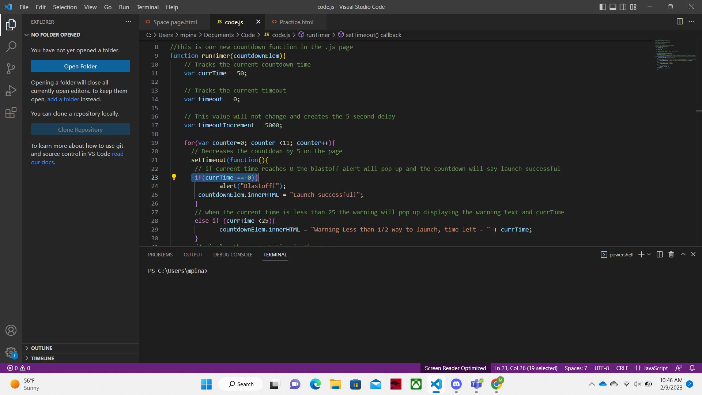The code I highlighted will be where I add the logic error. I will delete one of the “=” so that instead of creating the blastoff alert when currTime equals zero it will set currTime to zero.

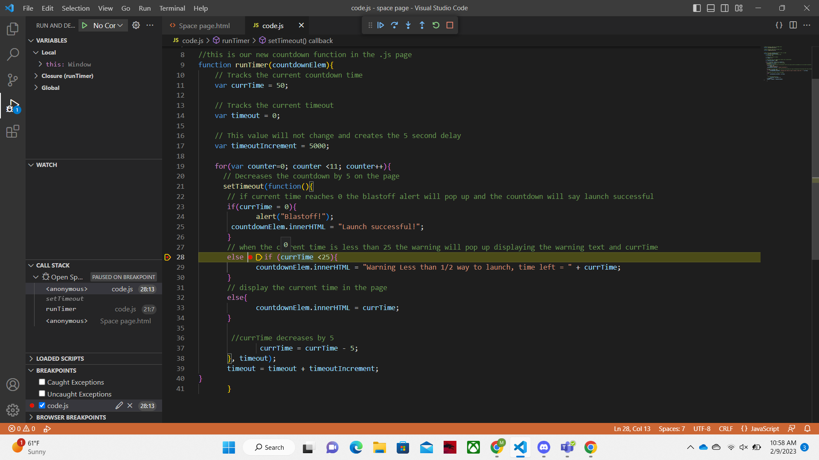As soon as line 23 is run the currTime value will be set to 0 instead 50. This is seen where the breakpoint is as hovering over currTime tells us the value is 0. Where the breakpoint needs to be is determined by where the issue seems to be. In our case the error is in line 23 so we would have to add a breakpoint in the next line of executable code to determine what currTime is being set to. The breakpoint was added at line 28 and I walked through the code until that point to see what currTime was being changed to.

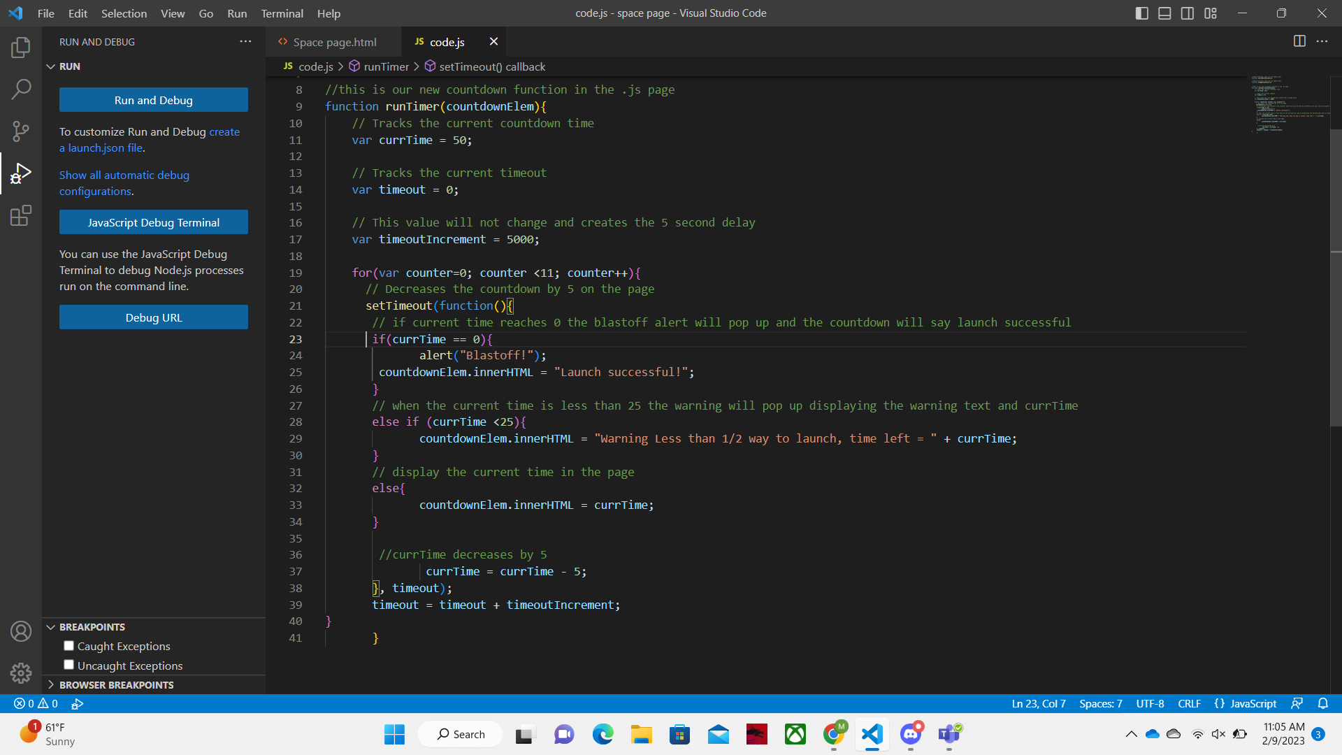Going through the code until the breakpoint shows that currTime is being set to 0. I then would go back to the code finding what above line 28 sets currTime to zero. Line 23 does this because it is missing one of the “=” which assigns currTime a value instead of saying if currTime equals 0 then the blastoff alert will play. I would have to add back the missing “=” sign to fix this code.